Lab — Provision an AKS (Azure Kubernetes Service) Cluster with Terraform

What you’ll build
A production-ready (but minimal) AKS cluster using Terraform with a system-assigned managed identity.

Prerequisites
- Terraform installed (v1.5+ recommended)
- Azure CLI installed (az) and logged in to the correct subscription
- kubectl installed (any recent version)
- An Azure subscription with permission to create resources

Learning objectives
By the end, you’ll be able to:
- Model an AKS cluster in Terraform
- Authenticate Terraform to Azure via Azure CLI
- Generate and use a kubeconfig safely (without manual editing)
- Validate the cluster and basic node health
- Cleanly destroy the environment

1) Authenticate to Azure
az login
az account show # confirm the right subscription
# If needed:
# az account set --subscription "<SUBSCRIPTION_NAME_OR_ID>"

Terraform will re-use your Azure CLI credentials automatically (no service principal needed for this lab).

2) Clone the Code Repository
Clone the code repository from here - Provision Kubernetes Cluster.

This repository has the code to provision AKS Cluster.

Update the following values in the terraform.tfvars file

prefix = "devops2-saurabh-d-aks"
location = "West Europe"
default_node_pool_name = "sau"

3) Initialize and apply
terraform init
terraform plan
terraform apply --auto-approve

4) Use the kubeconfig
To access the kubernetes cluster created above. We need to update the kube config file.

mv ~/.kube/config ~/.kube/config_backup

Copy the code from the output of the following command and paste in the ~/.kube/config file.

terraform output kube_config

You can also use the below commands to copy paste.

terraform output kube_config >> ~/.kube/config

Open the file and remove <<EOT and EOT from the ~/.kube/config file from the first and the last line of the file.

5) Validate the cluster
# Nodes ready?
kubectl get nodes
# Core namespaces healthy?
kubectl get pods -A
# Quick test workload
kubectl create deploy hello --image=nginx
kubectl expose deploy hello --port=80 --type=LoadBalancer
kubectl get svc hello -w

Wait for an external IP on hello service, then open it in a browser.
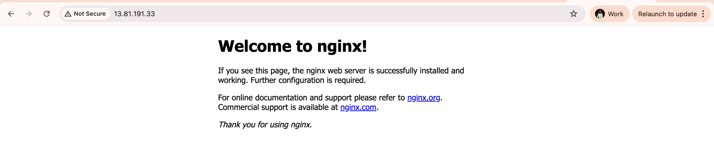

6) Troubleshooting tips
- Authorization failed/insufficient privileges: Ensure you’re logged into the correct subscription (az account show) and have Contributor/Owner.
- Provider version errors: Run terraform init -upgrade.
- No external IP on Service/LoadBalancer: Give it a few minutes; check kubectl describe svc hello for events.
- kubectl can’t connect: Verify KUBECONFIG path or current context with kubectl config get-contexts.

